

**E-Voting Portal**

Software User Manual

**Group Members -**

**1.G Srisha Anagh (IIT2016030)**

**2.Sai Charan Teja (IIT2016039)**

**3.Anmol Singh Sethi (IIT2016040)**

**4.Manavdeep Singh (IIT2016042)**

**5.Nairit Banerjee (IIT2016505)**

Table of Contents

1. **General Introduction**
2. **Basic Entities**
   1. Voter Table
   2. City Table
   3. Candidate Table
   4. Election Officer Table
   5. Constituency Table
3. **System Summary**
4. **General Introduction-**

Our project “E- Voting Portal” is a web application which helps ease the process of voting for a leader in the constituencies. The user has to register in the site and then has the choice to become a candidate. If he wishes to become a candidate, he is required to fill out and share certain files to check the validity - which the election officer verifies. Once the election officer (who is added/ removed by the admin) starts the election, the voters can all vote just once for their own candidate. Then once the elections are stopped, the results are displayed.

The website has attractive UI which makes it simple for the user to understand the functionality of the software.

1. **Basic Entities-**

There are five major entities defined for the use case of this website app. They are -

|  |  |
| --- | --- |
| **Serial Number** | **Name** |
| 1. | Voter |
| 2. | Candidate |
| 3. | Election officer |
| 4. | City |
| 5. | Constituency |

**The tables have the following attributes :**

# Voter Table :

* **Name -** Name of the user
* **Gender -** Gender of the user
* **DateOfBirth -** Date of Birth (to be selected from the calendar drop down)
* **AadhaarNumber -** 12 digit aadhaar number to be entered.
* **PinCode -** Pin Code of residing area.
* **MobileNumber -**  Currently active Mobile Number. OTP will be sent.
* **EmailId -** active Email ID in which confirmation will be sent.
* **Password -** Password to be entered. It is encrypted in SHA256.
* **VotingStatus -** Initially 0 once verified, made 1.

1. **City Table :**

* **PinCode -** PinCode entered by the user.
* **City -** name of the City.
* **State -** State the city is in.

1. **Candidate Table :**

* **AadhaarNumber -** Aadhaar of the candidate to be entered.
* **PhotoLink -** Upload Picture.
* **SignatureLink -** Upload picture of signature.
* **EduQua -** Enter educational qualifications.
* **Constituency-** Constituency the candidate wants to stand in.
* **NumberOfVotes -** Number of votes is added as a voter votes for the candidate.
* **Validate-** Election Officer validates the Nominees. It is set to 1 once it is done.

1. **ElectionOficer Table :**

* **UserId -** To identify the ElectionOfficer.
* **Constituency -** Name of the Constituency the EC resides in.
* **Password -** Entered by the EC.

1. **Constituency Table :** (This is for system’s internal assistance)

* **State -** State constituency belongs to.
* **ID -** Generated by the user.
* **StartStopElection -** Integer. Initially set to 0.
* **StartStopNomination-** Integer initially set to 0.
* **ShowHideResults** - Whether to show or hide results

1. **System Summary-**

First of all the user has to perform the following tasks :

1. Use the website and register themselves as voters with all the information required.
2. Once registered, login this would take you to the dashboard where you would have the option to nominate him/herself as a candidate.

Once the webapp is running the user will have the following functionality :

* 1. The webapp has one main layout where all the login forums are available as routes from there :

After clicking on the Register Link, the register page opens in which all the data (valid data) should be entered after which you must confirm your details by the otp and/or the email sent to the email entered.

* 1. **Register as a candidate -**

User will have to provide the details if they want to nominate themselves as a candidate. Firstly they have to click on to the link in the dashboard that says register as candidate.

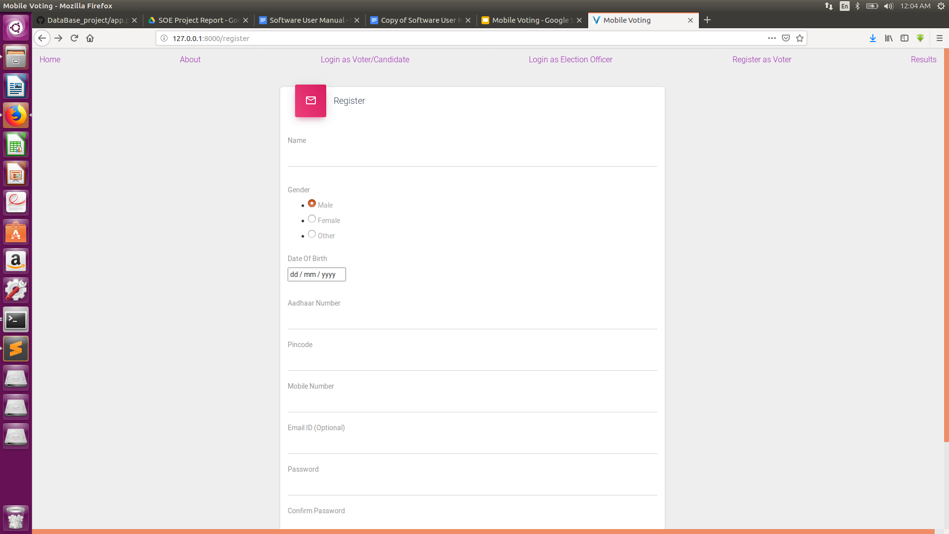

Then they have to enter the details necessary like photo, education qualifications etc.

Once you submit, that is entered into the table however until the election officer validates the candidate, you are not yet valid enough to be voted for.

Then after the election officer validates the candidate, you are a valid candidate. You can expect to be in the options of the voting list once the elections are begun.

* 1. **Elections Open/Close -**

Once the election officer opens elections for a particular constituency, the voters can cast vote.

Click the cast vote tab in the nav bar. This would redirect you towards the cast vote page.

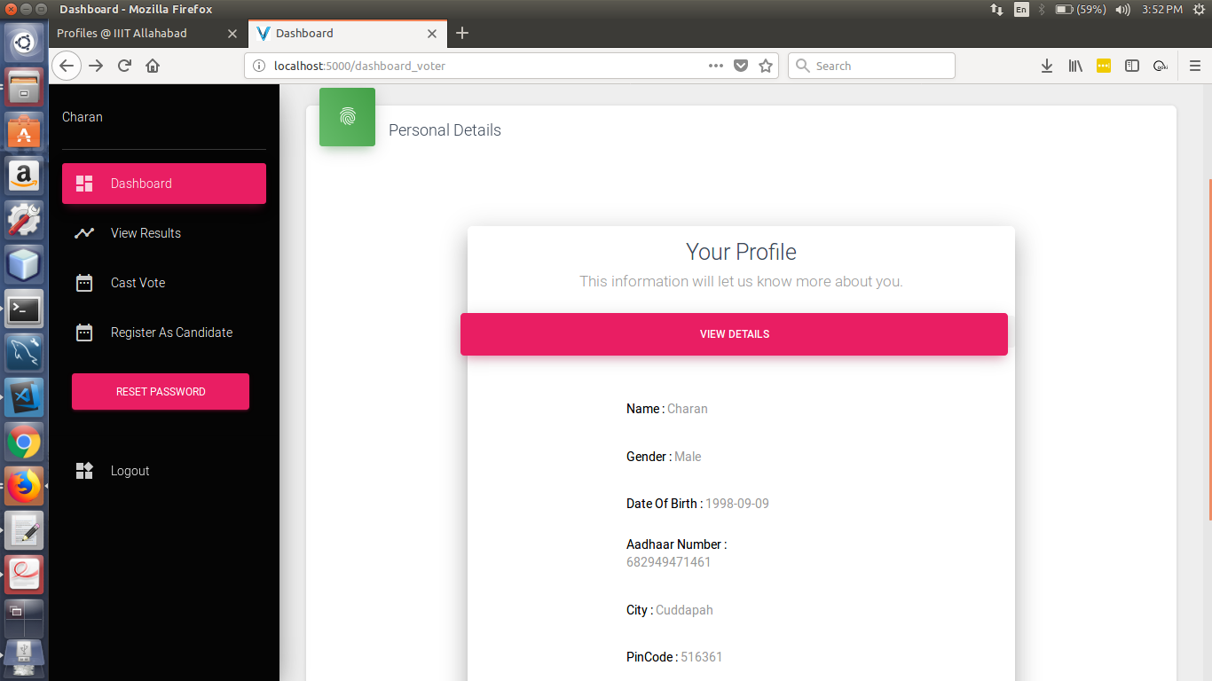

* 1. **Results show -**

Once the elections are stopped, the Number of Votes are displayed in the show results tab.

